|  |  |  |
| --- | --- | --- |
| **LAB 321Assignment** | **Type:** | **LongAssignment** |
| **Code:** | **J3.L.P0038** |
| **LOC:** | **150** |
| **Slot(s):** | **8** |

**Title:** User Management

**Background**

User management is the core function of any web application.

**Program Specifications**

In this assignment, you are requested to develop a simple user management system.

**Features:**

This system contains 4 main functions

* Function 1 : Add a new user (Pic 01)

One user should contains at least the following information

* + UserName
  + Email
  + FirstName
  + LastName
  + Password
  + Role
* Function 2 : User list ( PIC 02)
  + List all user available in the system
* Function 3 :Login ( see PIC 03)
  + In order to access the page user list, an authentication is required.
  + If the user has not authenticated, the system redirect to the login page (PIC 03)
  + The actor enters username and password, the function check if the username with the password is in the available user list, then grant the access permission. If not, a message would appear no notify that user is not found.

.

***Expectation of User interface:***

***(This prototype is creation by .Net IDE, so you do not need to design the user interface absolute accuracy , but all function must work properly)***

Pic 01 : Add a new user

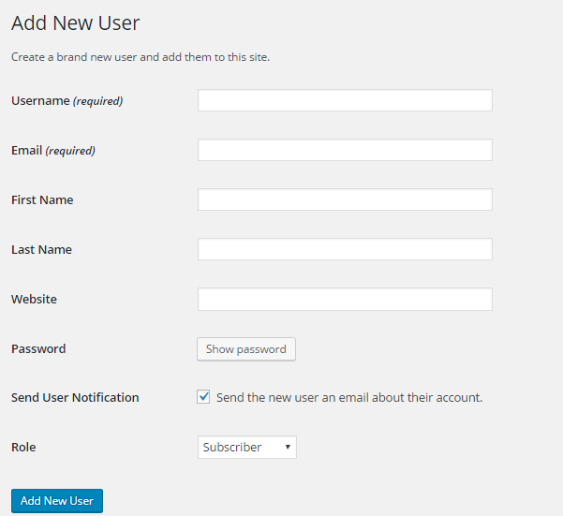

Pic 2: Show all user

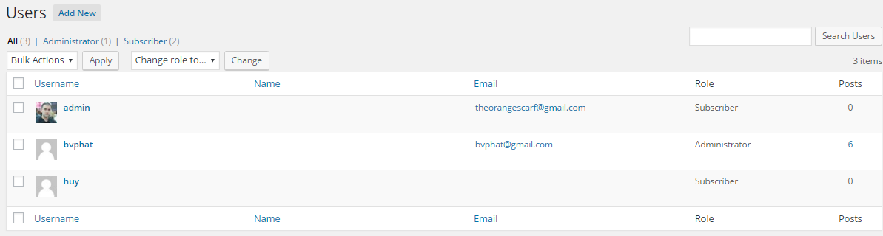

PIC 3: Login to the system

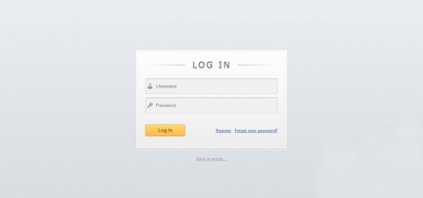

**Guidelines**

* Step 1 : Create web layout
* Step 2 : Create prototype
* Step 3 : Design database base on created prototype
* Step 4 : Code & Test